Assignment 1.1 The Doormans family
We have the following details about the pocket money within the Doormans family:
Truus gets € 19 per month, Lucas gets €4 per week and Miranda gets € 15 per quarter.
a. Calculate the total amount of pocket money that Truus, Lucas and Miranda get per month.
b. Calculate the total amount of pocket money that Truus, Lucas and Miranda get per week.

The inflation is 1.5%.
c. Calculate by how many euros the total pocket money of the 3 children must increase per year to be fully compensated for the increase in prices.
d. Explain that the actual increase in the total pocket money will probably be higher than the amount calculated in question c.

Assignment 1.2 Budget line
Fatih works at an office and in the afternoon he always goes to the same lunchroom for a grilled cheese/tomato sandwich and one or two cups of tea. Fatih wants to spend no more than € 36 per week on tea and a grilled cheese/tomato sandwich. A grilled cheese/tomato sandwich costs € 3 and a cup of tea € 2.
a. Draw the accompanying budget line. The number of cups of tea is shown on the horizontal axis and the number of cheese / tomato sandwiches on the vertical axis.
b. Calculate how many cups of tea Fatih can order if he orders six grilled cheese/tomato sandwiches every week.

Suppose the price of a grilled cheese/tomato sandwich rises from € 3 to € 3.60.
c. Draw the new accompanying budget line.
d. Calculate how many cups of tea Fatih can then still order at the most if he also orders six grilled cheese/tomato sandwiches again every week.
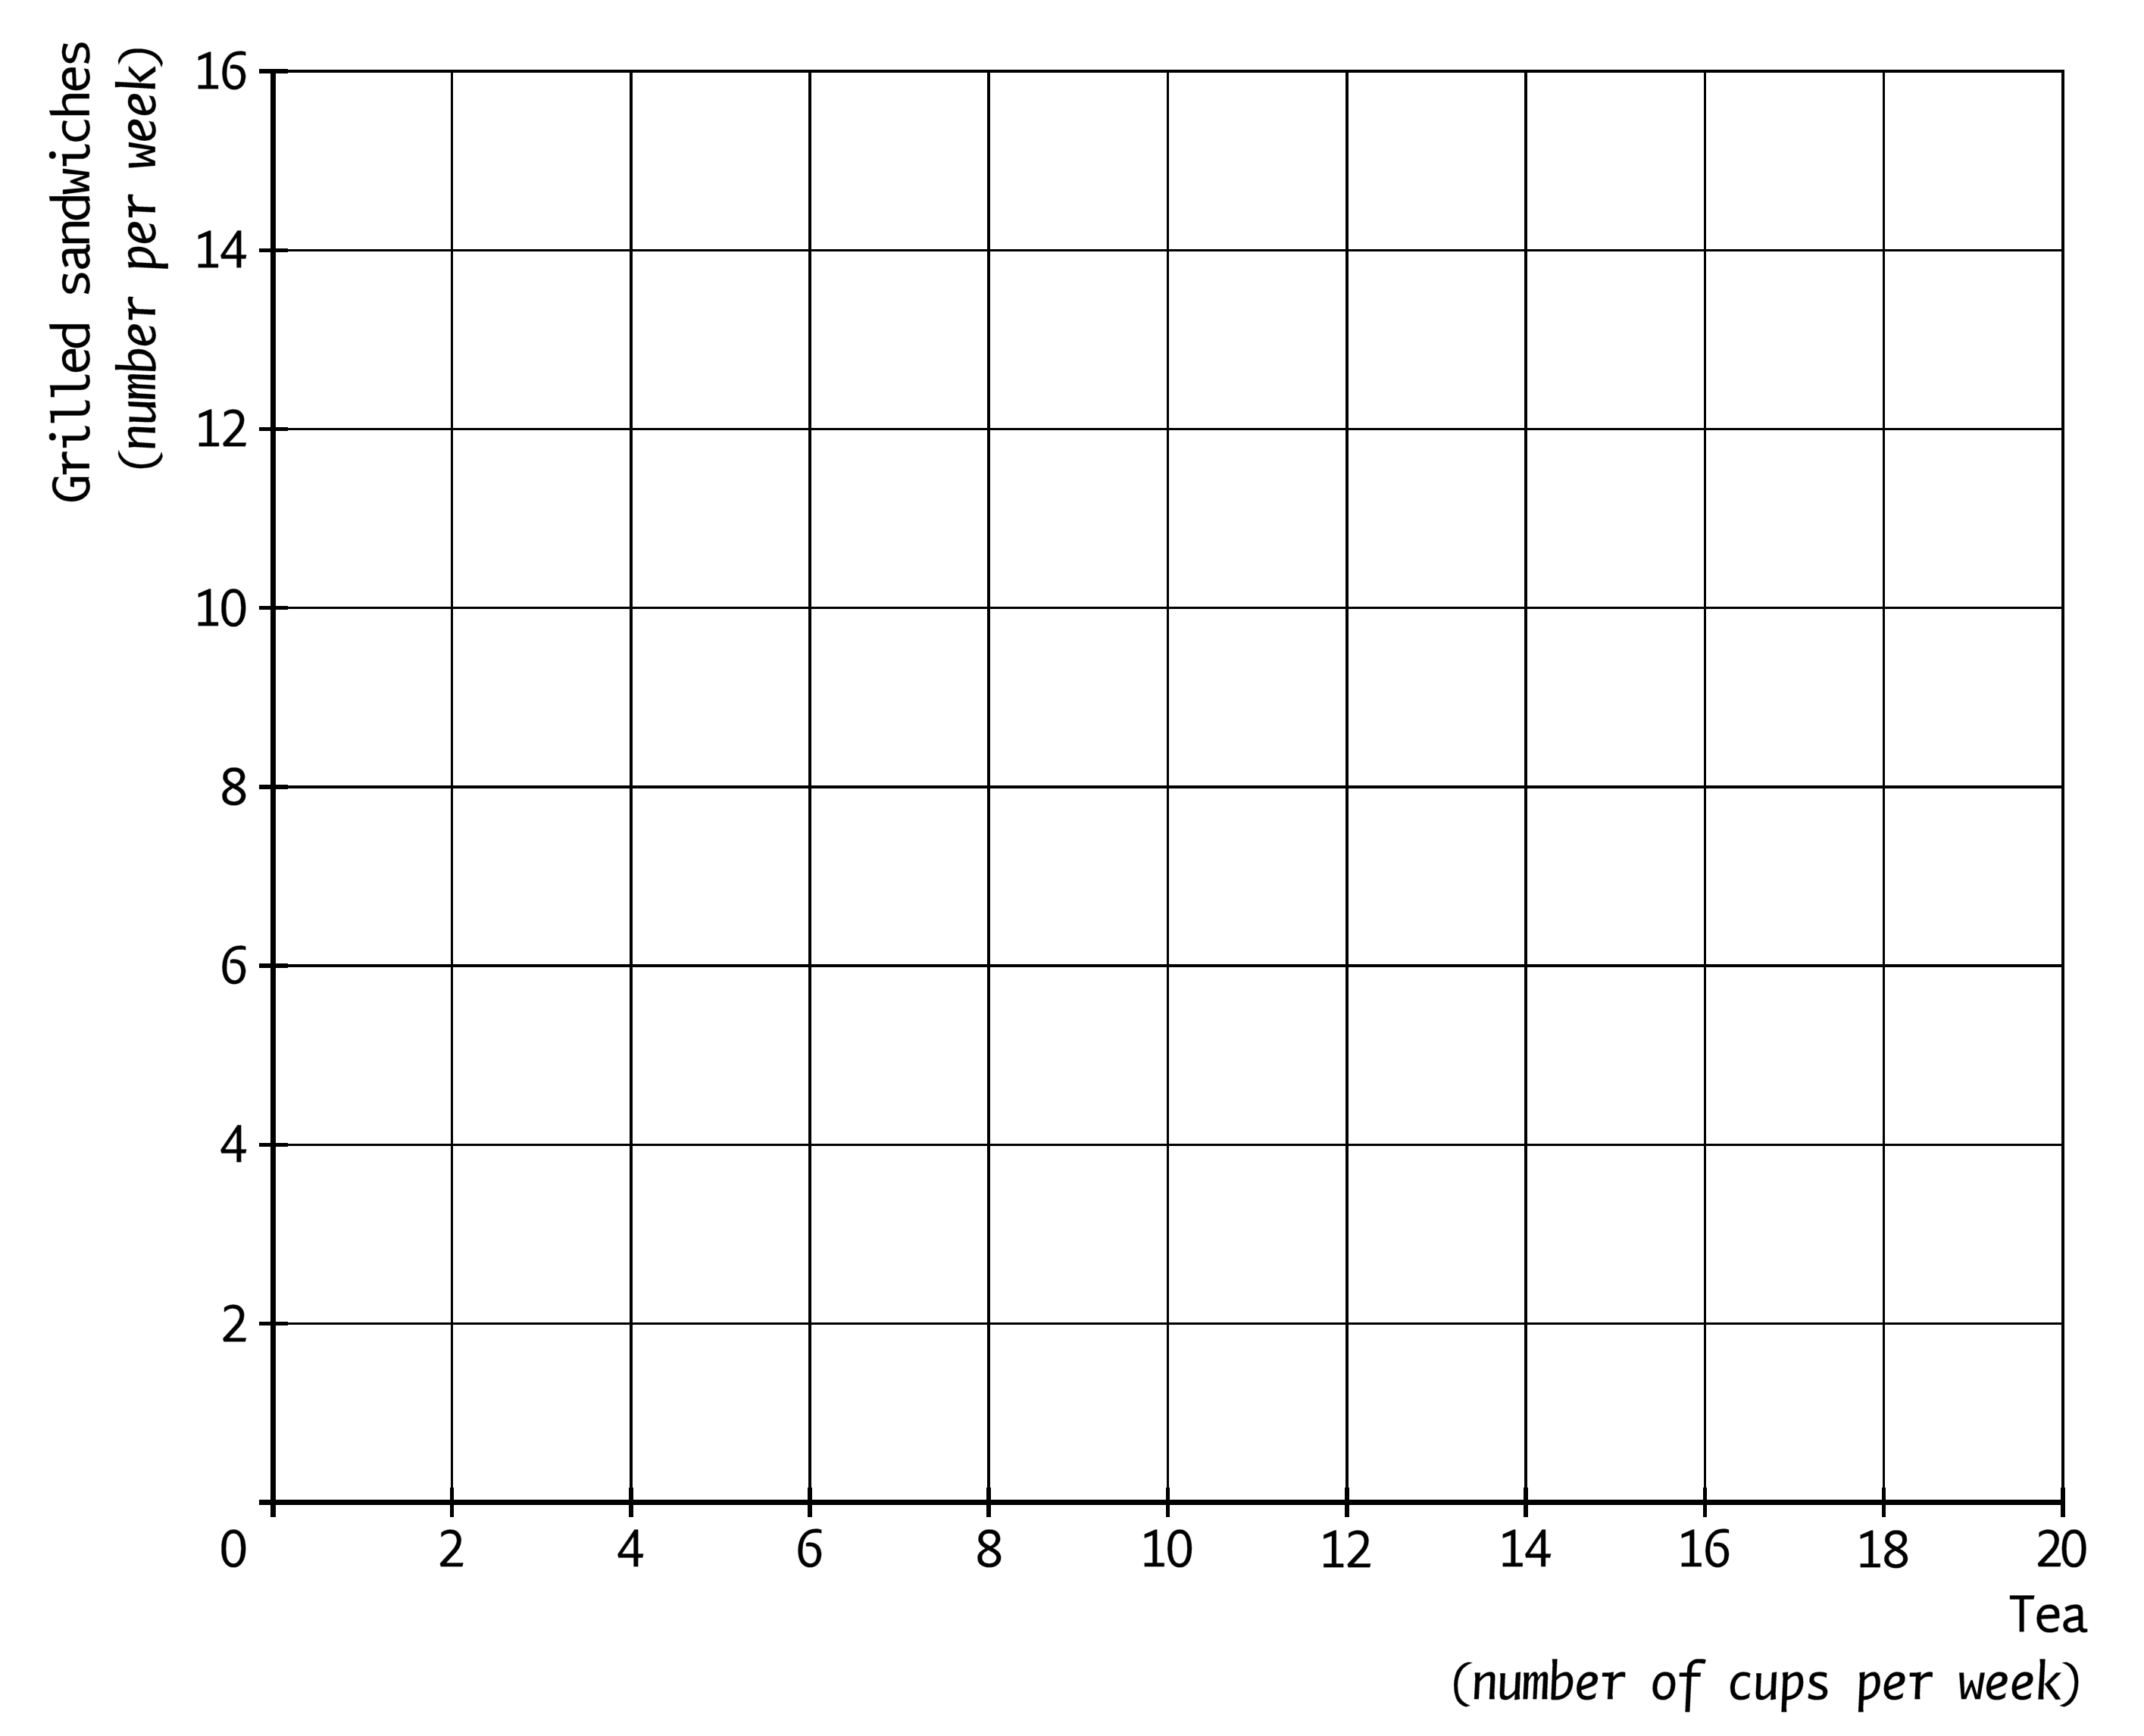

Assignment 1.3
a. Use the sentences below to compose an economically correct text.
The money which you spend on your shopping every day or week is called …(1)…. Premiums for insurances, subscriptions, membership fees and travelling and transport costs to school or work fall under the …(2)….
…(3) … is putting money aside for bigger expenses that occur less frequently such as the purchase of a new kitchen or a car.
Choose from:
at (1) daily money / household expenses / fixed charges
at (2) fixed charges/ periodic expenses / household expenses
at (3) saving / reserving/ repaying

The Van Binsbergen family decides to insulate their house. They intend to borrow the money for the insulation of their house.
b. Under which kind of expenses do the costs fall for the loan for insulation of their house?
A Under daily expenses
B Under non-recurring expenses
C Under fixed charges

Jan phones a repairman to repair the radiator. After the repair he receives an invoice of €203.00.
c. Under which kind of expenses does this repair fall?
A Daily expenses
B Household expenses
C Reserve expenses
D Fixed charges

Anne has the following expenses in July:
1 | shopping at the supermarket | € 256
2 | rent | € 650
3 | membership fee gym | € 29
4 | daughter’s pocket money | € 10
5 | two State Lottery tickets | € 30
6 | new sofa for the living-room | € 750
7 | insurance premium for the moped | € 15
8 | contract costs smartphone | € 35
9 | money for a visit to the cinema | € 20
10 | new clothes for daughter | € 65

Total expenses = € 1,860.
Anne’s income in July consists of € 900 in wage and € 250 in child benefit. She has withdrawn the money for the purchase of the sofa from her savings account.
d. Calculate the amount of the household expenses in July.
e. Calculate the amount of the fixed charges in July.
f. How much are the reserve expenses in July?
g. Calculate the amount of the surplus or the deficit which Anne has in July.

Computations

Assignment 1.1
a. 19 + (4 × 52)/12 + (15 × 4)/12 = 19 + 17.33 + 5 = € 41.33.
b. (41.33 × 12)/52 = € 9.54.
c. Pocket money per year = 19 × 12 + 4 × 52 + 15 × 4 = € 496.
0.015 × 496 = € 7.44.
d. Because every child is getting a year older, which is usually a reason for parents to raise the pocket money.

Assignment 1.2
a. See figure.
b. (36 ─ 6 × 3)/2 = 18/2 = 9. So 9 cups of tea.
c. See figure.
d. (36 ─ 6 × 3.6)/2 = 14.40/2 = 7.2. So 7 cups of tea.

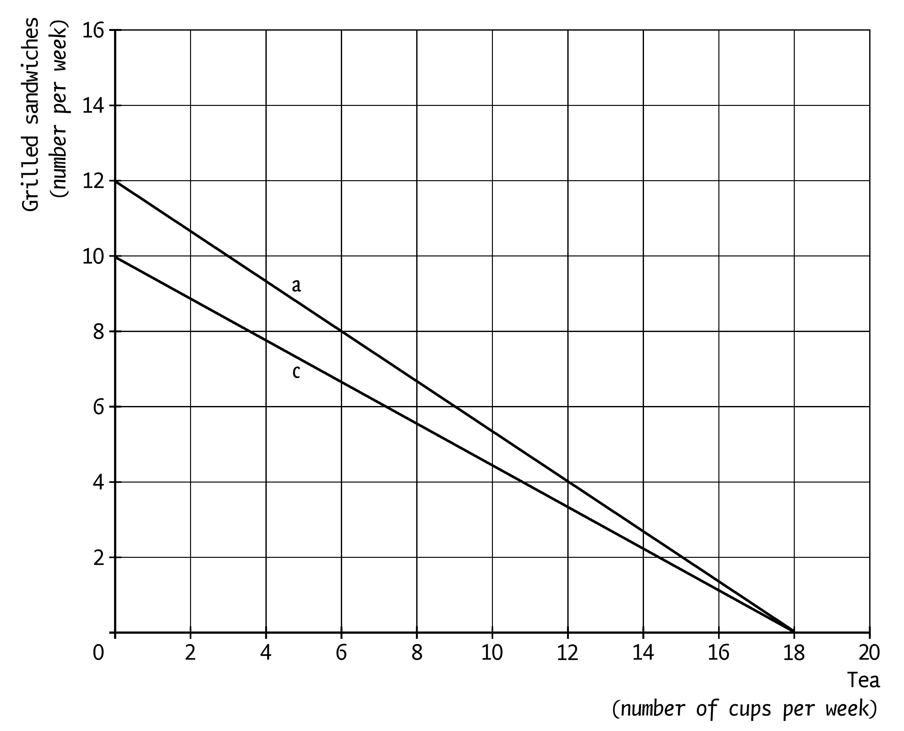
Assignment 1.3
a. At (1) household expenses, at (2) fixed charges and at (3) reserve.
b. C
c. C
d. 256 + 10 + 30 + 20 + 65 = € 381.
e. 650 + 29 + 15 + 35 = € 729.
f. €750
g. Total ‘receipts’ = 900 + 250 + 750 (withdrawn from the savings account) = € 1,900.
Total expenses = 381 + 729 + 750 = € 1,860.
Surplus = € 1,900 – € 1,860 = € 40.

