Assignment 2.1 The Doormans family
Twenty years ago Peter and Els Doormans got married and they now have three children, Truus, Lucas and Miranda. Peter works fulltime as a teacher at Udens College and earns €3,699 per month. Els used to work at the finance department of the Hogeschool in Nijmegen for four days a week and earned an income of €3,489. A reorganisation of the finance department cost Els her job and that is why she is now at home receiving an unemployment benefit. The unemployment benefit amounts to 70% of her former income.
Truus is 19 years old and follows a speech therapy course at the university of applied sciences in Nijmegen. Every weekend she works in Brasserie De Conversatie in Uden. Truus works there for 12 hours and earns €96 per weekend. Lucas, 16, is in his final havo year and works on Saturdays as a shelf stacker at Jumbo. Lucas works 8 hours and earns €48. Miranda is 15 years old and attends vmbo. Miranda has a newspaper round and earns €130 per month. Every week the children get pocket money from their parents. Truus gets €19, Lucas €16 and Miranda €15. Apart from this, all three get €100 clothing money every month.
Each quarter Peter and Els get child benefit. This amounts to €633 per quarter.
a. Calculate the total primary monthly income of the Doormans family.
b. Calculate the total monthly income of the Doormans family.
c. Calculate the total weekly income of the Doormans family.
d. Under which kind of incomes do the unemployment benefit and the child benefit fall which the Doormans family receives?
e. Calculate the total amount of pocket money which Truus, Lucas and Miranda get per month.

Assignment 2.2 Watercress nursery
Eelco Weghorst is specialised in growing watercress. Eelco’s nursery has a storage area in which the watercress is packaged and stored in cold storage containers. Eelco rents the storage area for €900 per month. Eelco leases the plot of land on which the watercress is grown. The lease amounts to €200 per month. The watercress is grown in large plastic trays, fitted with an input and exhaust system for salt water. In the cultivation of watercress it is essential that the tidal effect at sea is mimicked as closely as possible. The total investment in the water system amounted to €87,500. The water system was financed with a bank loan. This year Eelco pays €6,300 interest.
Eelco has three employees in paid employment. The annual wage costs amount to €38,000 per employee. This year Eelco cleared a nice profit of €90,450.
a. In the story, examples are mentioned of factors of production. Fill in the table below. Always mention the factor of production concerned and what the name of the reward is that is received for it.

 | factors of production | reward
Eelco Weghorst
employees
plot of land
storage area
water system

b. Complete the table below for Eelco Weghorst’s nursery by filling in the amounts.

wages | €
lease | €
interest | €
rent | €
profit | €

Assignment 2.3 Lorenz curve
During an economics lesson the income distribution in the Netherlands is discussed and pupils from class 3 study the Lorenz curve below of the Netherlands.
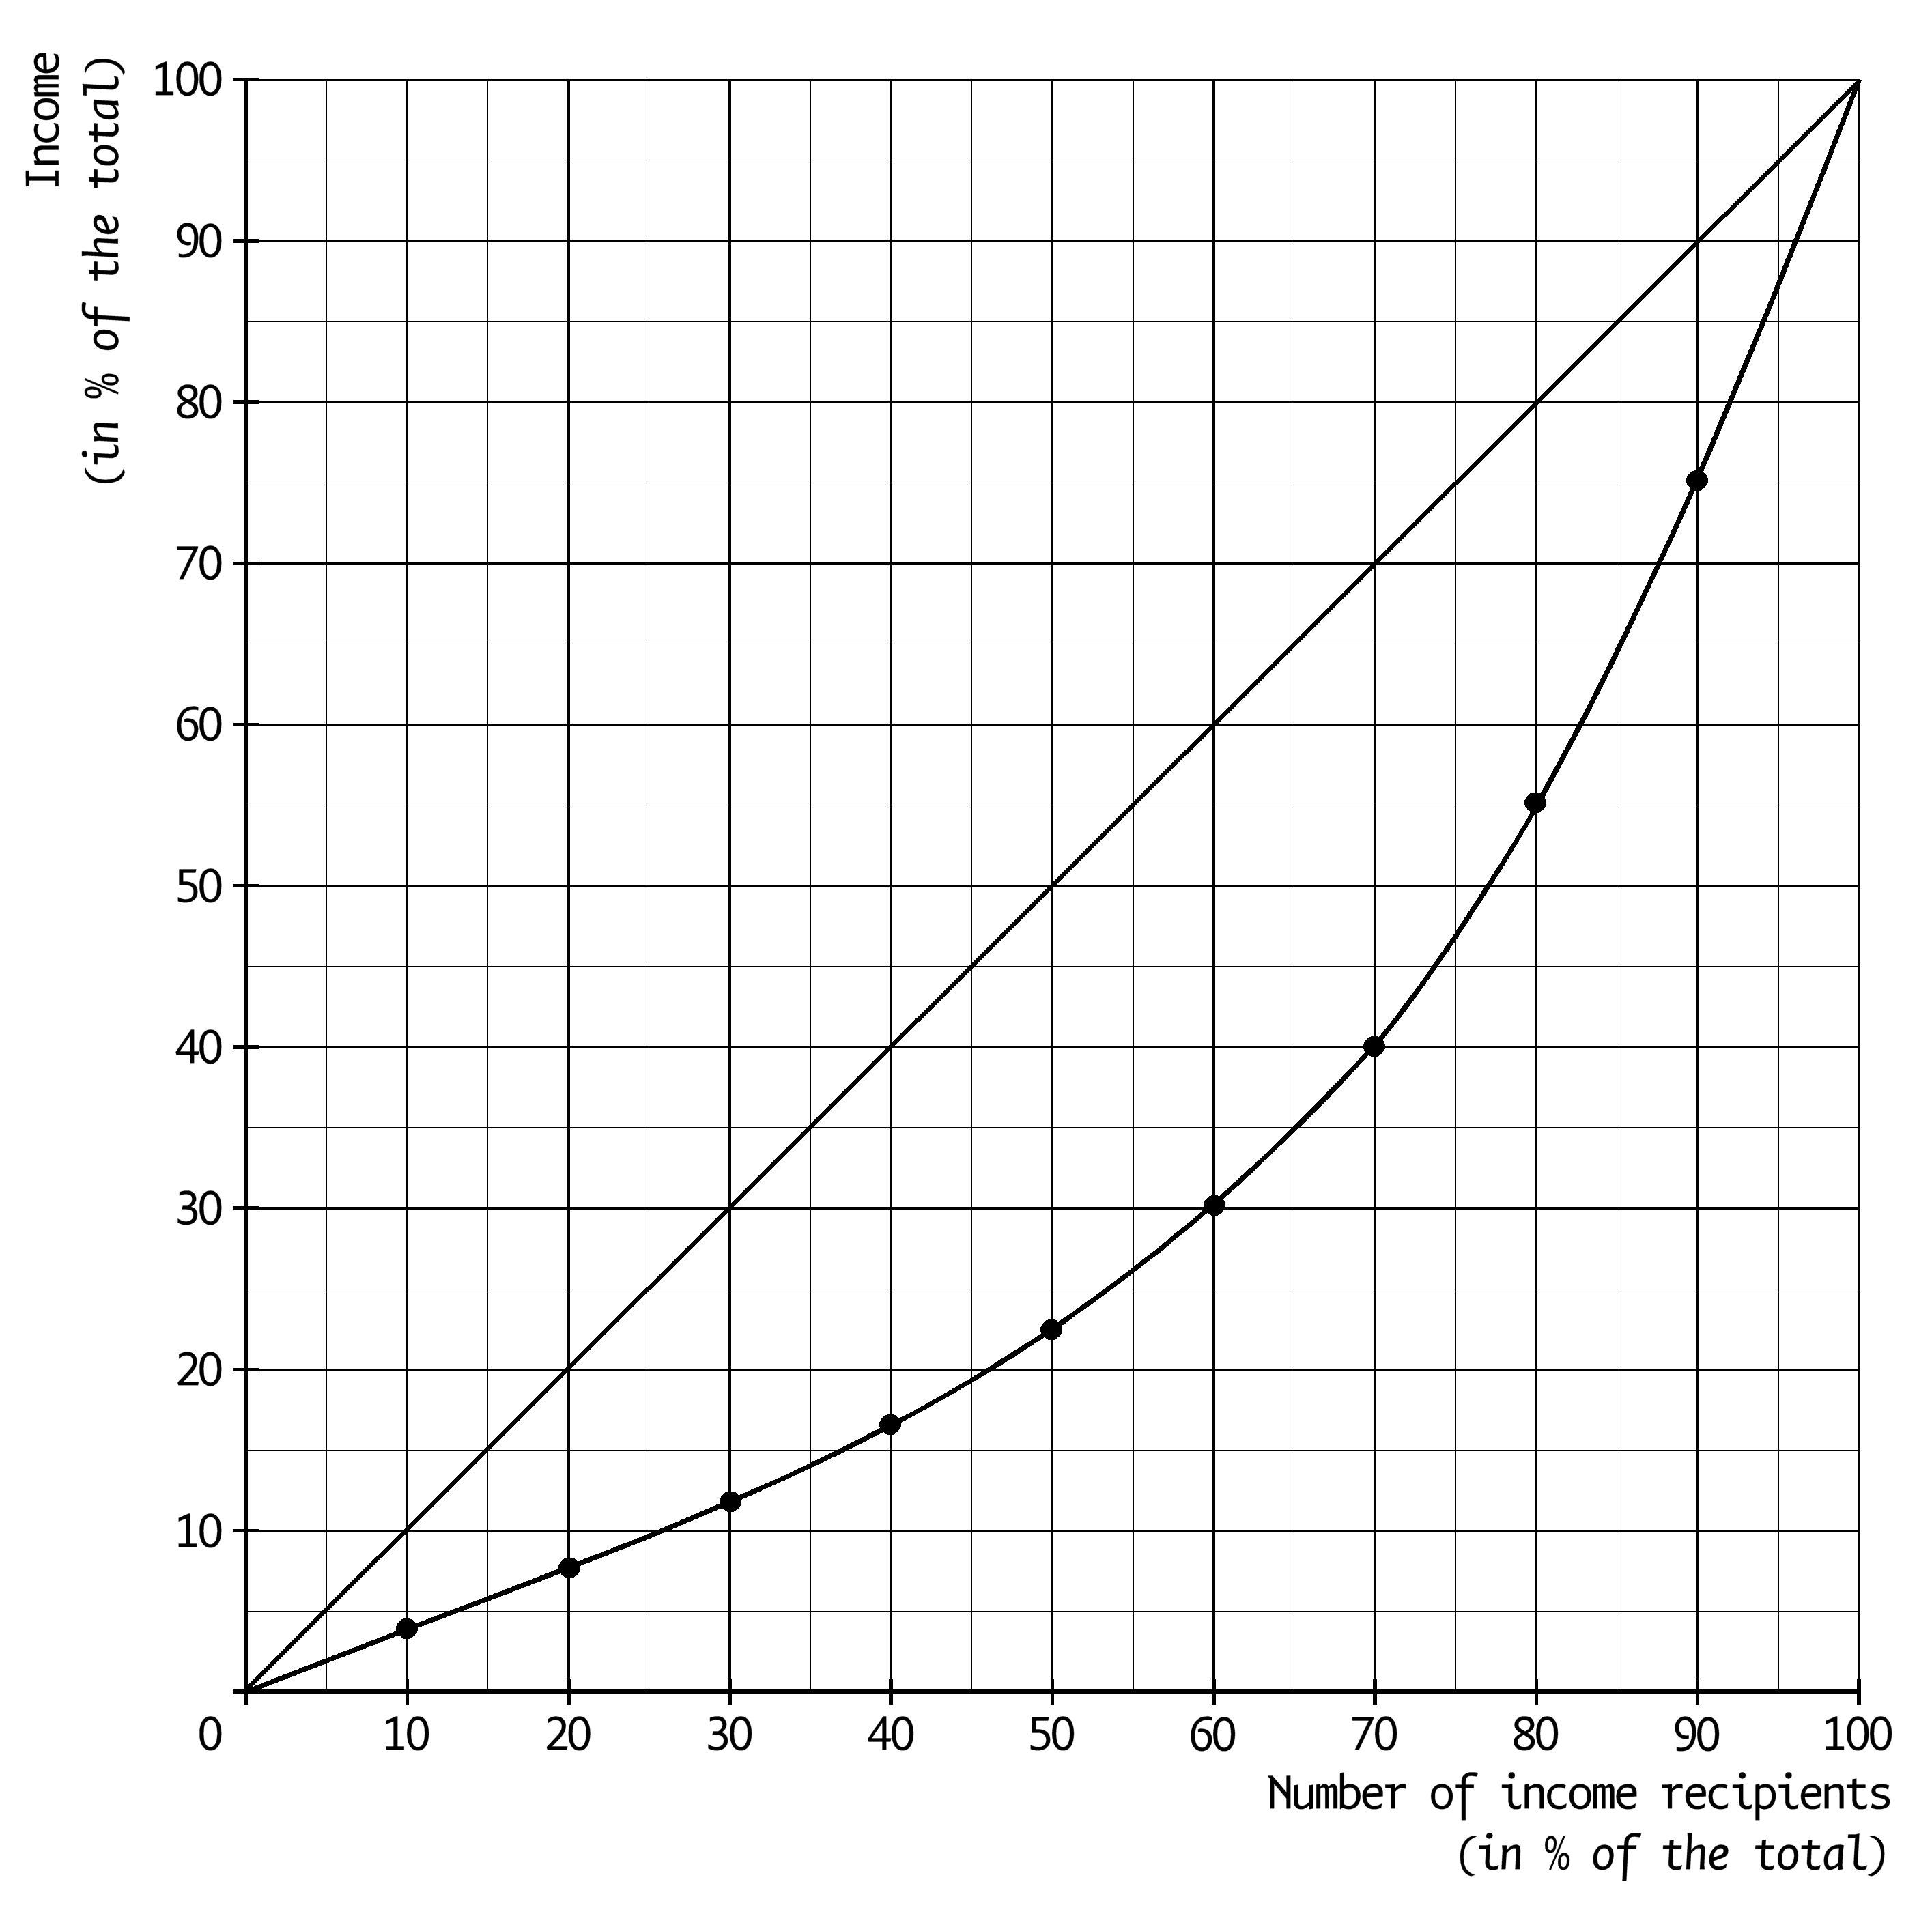
a. Use the above Lorenz curve and use the sentences below to compose an economically correct text by selecting the right words.
The closer the Lorenz curve is to the diagonal, the …(1)… (more equal / more unequal) the income distribution. The 10% of persons with the lowest incomes earn …(2)…
(4% / 9% / 20%) of the total income. The 10% of persons with the highest incomes earn …(3)… (25% / 75% / 90%) of the total income.

The income recipients in the above Lorenz curve have been classified in groups of 10%. Such a 10%-group is called a decile. A further given is that it concerns 12 million income recipients and that the total income amounts to €700 billion.
b. Calculate the amount of the average income per person in the 7th decile in whole euros.

The income in the above Lorenz curve consists of primary incomes and transfer incomes. Suppose that no account is taken of transfer incomes.
c. Will the Lorenz curve then be closer to the diagonal line or farther away from it? Explain the answer.

Computations

Assignment 2.1
a. 3,699 + 52/12 × 96 + 52/12 × 48 + 130 = €4,453.
b. 3,699 + 0.7 × 3,489 + 52/12 × 96 + 52/12 × 48 + 130 + 633/3 = €7,106.30.
c. 7,106.30 × 12/52 = €1,639.92.
d. Transfer incomes.
- (19 + 16 + 15) × 52/12 = €216.67.

Assignment 2.2
a.
 | factors of production | reward
Eelco Weghorst | entrepreneurship | profit
employees | labour | wage
plot of land | nature | lease
storage area | capital | rent
water system | capital | interest

b. wages = 3 × 38,000.
lease = 12 × 200.

wages | € | 114,000
lease | € | 2,400
interest | € | 6,300
rent | € | 10,800
profit | € | 90,450

Assignment 2.3
a. (1) more equal. (2) 4%. (3) 25%.
b. In the 7th decile it concerns 10% of the income recipients = 0.1 × 12 million = 1.2 million.
Together they earn exactly 10% of the total income = 0.1 × €700 billion = €70 billion.
Per person that is €70 billion/1.2 million = €58,333.33.
c. Farther away from the diagonal line. The transfer incomes end up mainly with the people with the lowest incomes and if these transfer incomes are taken away, the income differences will become bigger.

