Assignment 6.1 Trade in calculators
On a market, calculators are traded. In the initial situation the following applies:

Qd = -0.75P + 30 Qd = demand for calculators × 100,000.
Qs = 1.25P – 14 Qs = supply of calculators × 100,000.
P = price per calculator in euros.

a. Calculate the equilibrium price that will arise in the initial situation.
b. Calculate the number of calculators traded in the initial situation.
c. Draw the demand curve (D1) and the supply curve (S1) of calculators in the figure.
d. What is the maximum (highest) price which consumers of calculators are willing to pay for a calculator?
e. What is the lowest price which a supplier of calculators will want to have?

Rumour has it that calculators are going to be forbidden in the first year of secondary school. Consumers respond to this so that a new demand function arises:

Qd' = -0.75P + 26.
The supply function continues to be Qs = 1.25P – 14.

f. Draw the new demand curve D2 in the figure.
g. Calculate by what percentage the turnover of calculators will decrease in comparison with the initial situation.
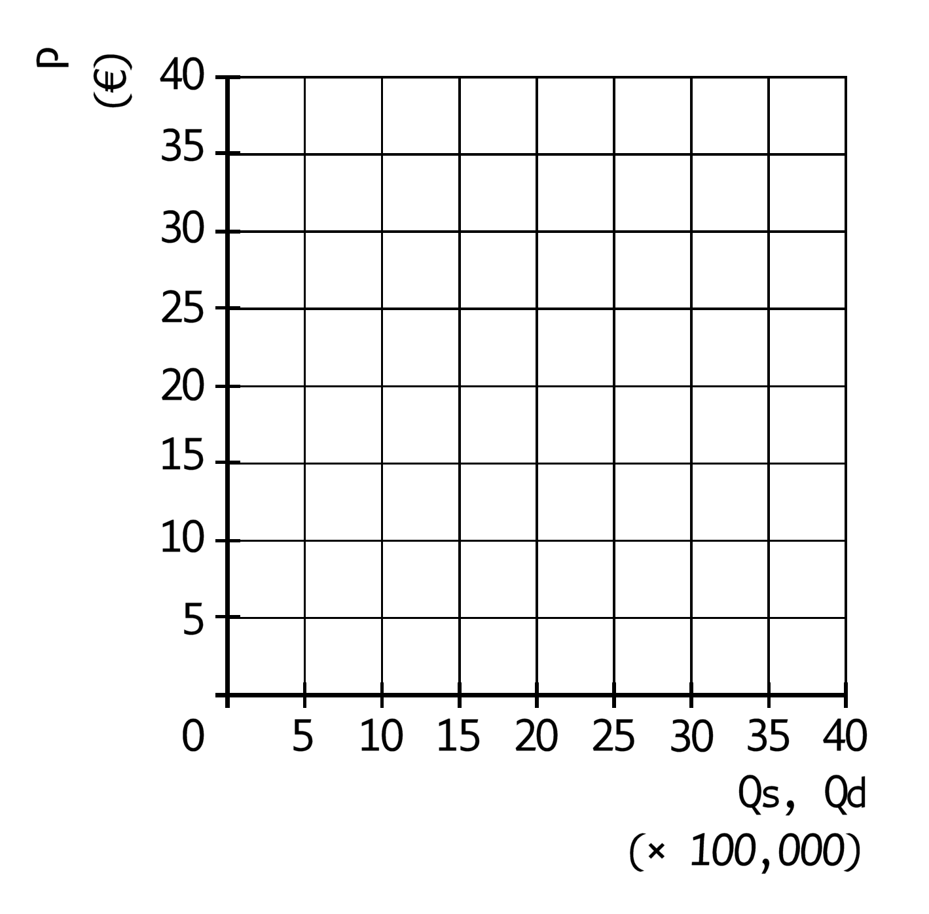

Assignment 6.2
The CBS has collected data for the Netherlands, see the table. The data relates to July 2013 and the numbers have been rounded off.
Table of CBS: in persons
unemployed  employees  self-employed  vacancies | 600,000  6,200,000  1,100,000  90,000

Use the data to calculate:
- The demand for labour.
- The supply of labour.
- The employment.

Assignment 6.3
In country B the working population numbers 6 million people. The average labour productivity is €40,000. At this moment the total production value is €220 billion.

a. Calculate what percentage of the working population is unemployed at this moment
b. Calculate the maximum production value in country B.

One year later the labour productivity has risen by 5%, while the total production value has risen by 8%. The working population has remained the same.
c. Will the unemployment rate in country B be the same, higher or lower than the previous year? Explain the answer without doing a calculation.

Assignment 6.3
Look at the table below.
Countries | Production | Employment
A | + 3% | ─ 1%
B | + 2% | + 3%
C | + 4% | + 2%

In which country or countries has the labour productivity risen? Explain your choice.

Computations

Assignment 6.1
- Qd = -0.75P + 30.
Qs = 1.25P – 14.
Qs = Qd → 1.25P – 14 = -0.75P + 30 → 2P = 44 →→ P = 22, the price is €22.
- Q = 1.25 × 22 – 14 = 13.5 so 1,350,000 calculators are traded.
- See graph.
- €40.
- €10.
- See graph.
- Qs = 1.25P – 14, Qd = -0.75P + 26.
Qs = Qd → 1.25P – 14 = -0.75P + 26 → 2P = 40 → P = 20, the price is €20.
Q = 1.25 × 20 – 14 = 11, so 1,100,000 calculators are traded.
The turnover in the new situation amounts to 1,100,000 × €20 = €22 million.
The turnover in the initial situation amounted to 1,350,000 × €22 = €29.7 million.
The turnover changes by (22 ─ 29.7)/29.7 × 100% = -25.9%.
A drop by 25.9%.

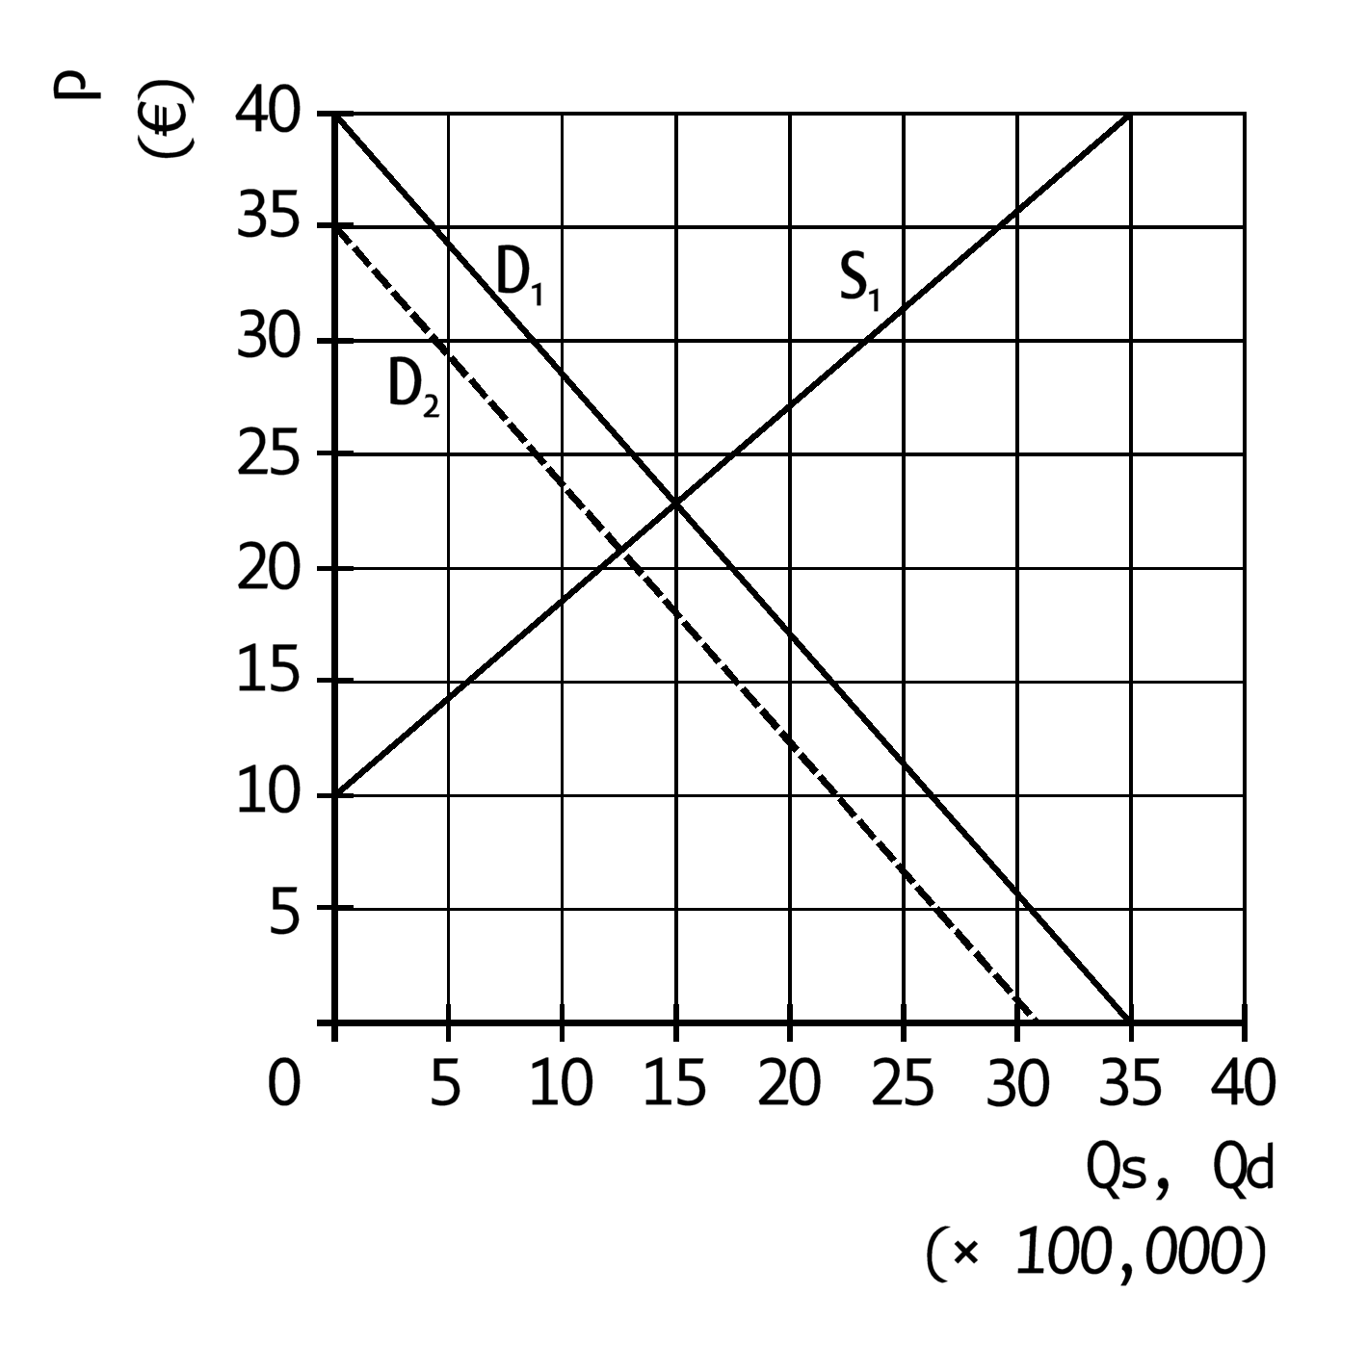

Assignment 6.2
- 6,200,000 + 1,100,000 + 90,000 = 7,390,000.
- 600,000 + 6,200,000 + 1,100,000 = 7,900,000.
- 6,200,000 + 1,100,000 = 7,300,000.

Assignment 6.3
- Number of workers = €220 billion/€40,000 = 5.5 million. Number of unemployed = 6 million – 5.5 million = 0.5 million. In a percentage of the working population this is 0.5/6 × 100% = 8.3%.
- 6,000,000 × €40,000 = €240 billion.
- Lower. The increase in the production value is greater than the increase in the labour productivity, so that more workers are needed on balance. Since the working population has remained equally big and there are now more workers, the number of unemployed persons has dropped and so has the unemployment rate.

Assignment 6.4
- In country A, because more is produced there with fewer workers. This is possible only if more is produced per worker.
- In country C, because the production has increased more than the number of workers. This is possible only if more is produced per worker.

