Exercise 1.1 Price movement of the British pound sterling.
The graph shows the exchange rate of the euro in comparison with the British pound sterling.
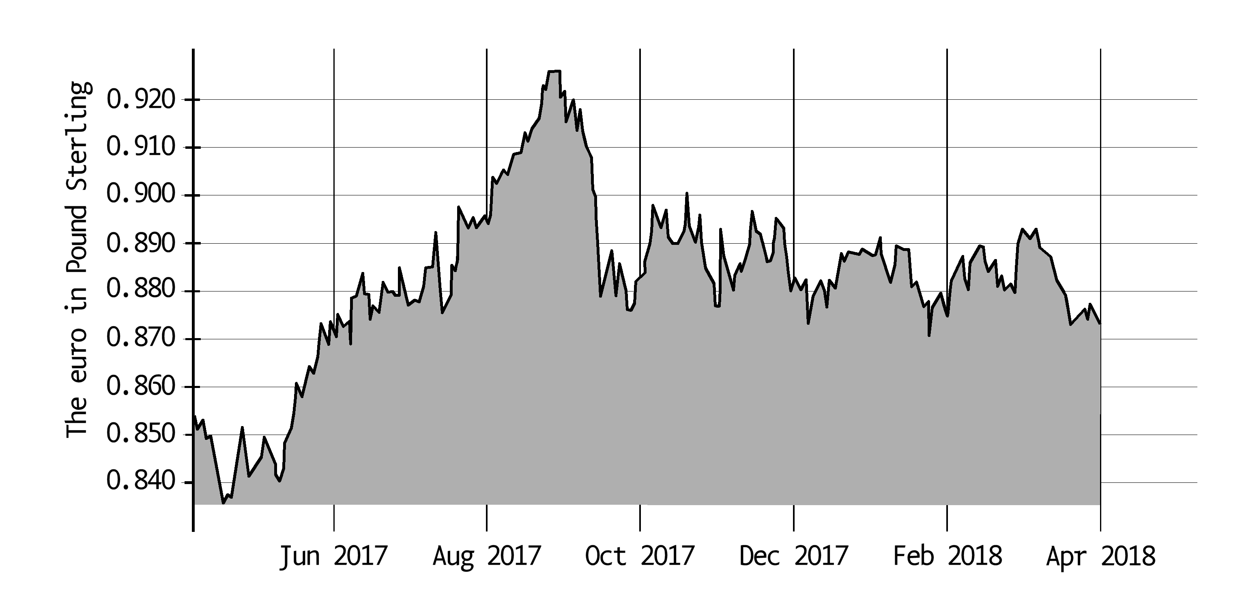

Has the British pound sterling increased or decreased in value in comparison with the euro between Mai 2017 and September 2017?

Exercise 1.2
Paul and Gus are going to London for the weekend. They have already booked the trip and the hotel has already been reserved. In order to go out in London they need English pounds. At a bank they buy English pounds sterling (GBP) for € 600. The exchange rate at that moment is GBP1 = €1.27. When they come back from London they have exactly 60 English pounds sterling left. They change them again at the bank. The exchange rate has changed then. For 1 euro they then receive 0.76 English pounds sterling.
- Calculate how many British pounds they have received for the €600.
- Calculate how much money they have spent in London.

Exercise 1.3 Yen and Dollar
A tourist from Japan buys an iPad in America. He pays $399 for it.
Calculate how much the iPad costs in yens, given the following exchange rate:
€1 = $1.22
€1 = 147.08 yen

Exercise 1.4 Coffee
Coffee is an important commodity in the world. Around 25 million farmers in 80 countries live off the yield of their coffee harvest. In some years, especially in 2010, they have no reason to complain: never before in this century was coffee so expensive. The high price also comes with drawbacks, though.

According to Roel Vaessen, secretary of the European Coffee Federation, on average 2 per cent more coffee is drunk every year. At present supplies are tight. Drought has affected the harvest in Latin America. Also, in Colombia many farmers have over the past few years replaced their coffee plants by new ones. A young plant only yields a good harvest after three years. As a result, Colombia was affected by a lower harvest.
According to: Fairtrade appendix, Trouw, 23 October 2010

In September 2010 the average price of 1 pound (0.453 kilo) of coffee was 163 dollar cent. In September 2005 a pound of coffee cost 78 dollar cent.
- Calculate in two decimals by what percentage the price of a pound of coffee has risen between September 2005 and September 2010.

Apart from market influences other than failed harvests, speculators turn out to be responsible for rising prices. Speculators buy up large batches of coffee in order to resell them at a profit later.
Below you find five economic phenomena.
1. buy up a batch of coffee beans
2. prices on the world market are increasing
3. a batch of coffee is stored
4. supply on the world market is decreasing
5. sell a batch of coffee at a profit

- In which line are the phenomena in an order presenting a logical line of reasoning?
A. 1 → 2 → 3 → 4 → 5
B. 1 → 2 → 4 → 3 → 5
C. 1 → 3 → 2 → 4 → 5
D. 1 → 3 → 4 → 2 → 5
E. 1→ 4 → 2 → 3 → 5
F. 1→ 4 → 3 → 2 → 5

More and more buyers are active on the world market who work for producers using hallmarks. Examples of such hallmarks are Max Havelaar and Utz Certified.
The point of departure of these hallmarks is fair trade. As a result, coffee farmers are paid a minimum price. This price guarantees that the coffee farmers can break even.
Figure 1 shows a market situation.
- How high is the minimum price of Fairtrade?
A. 50 dollar cent
B. 125 dollar cent
C. 175 dollar cent
D. 225 dollar cent

Figure 1. Average coffee prices per year in dollar cent per pound

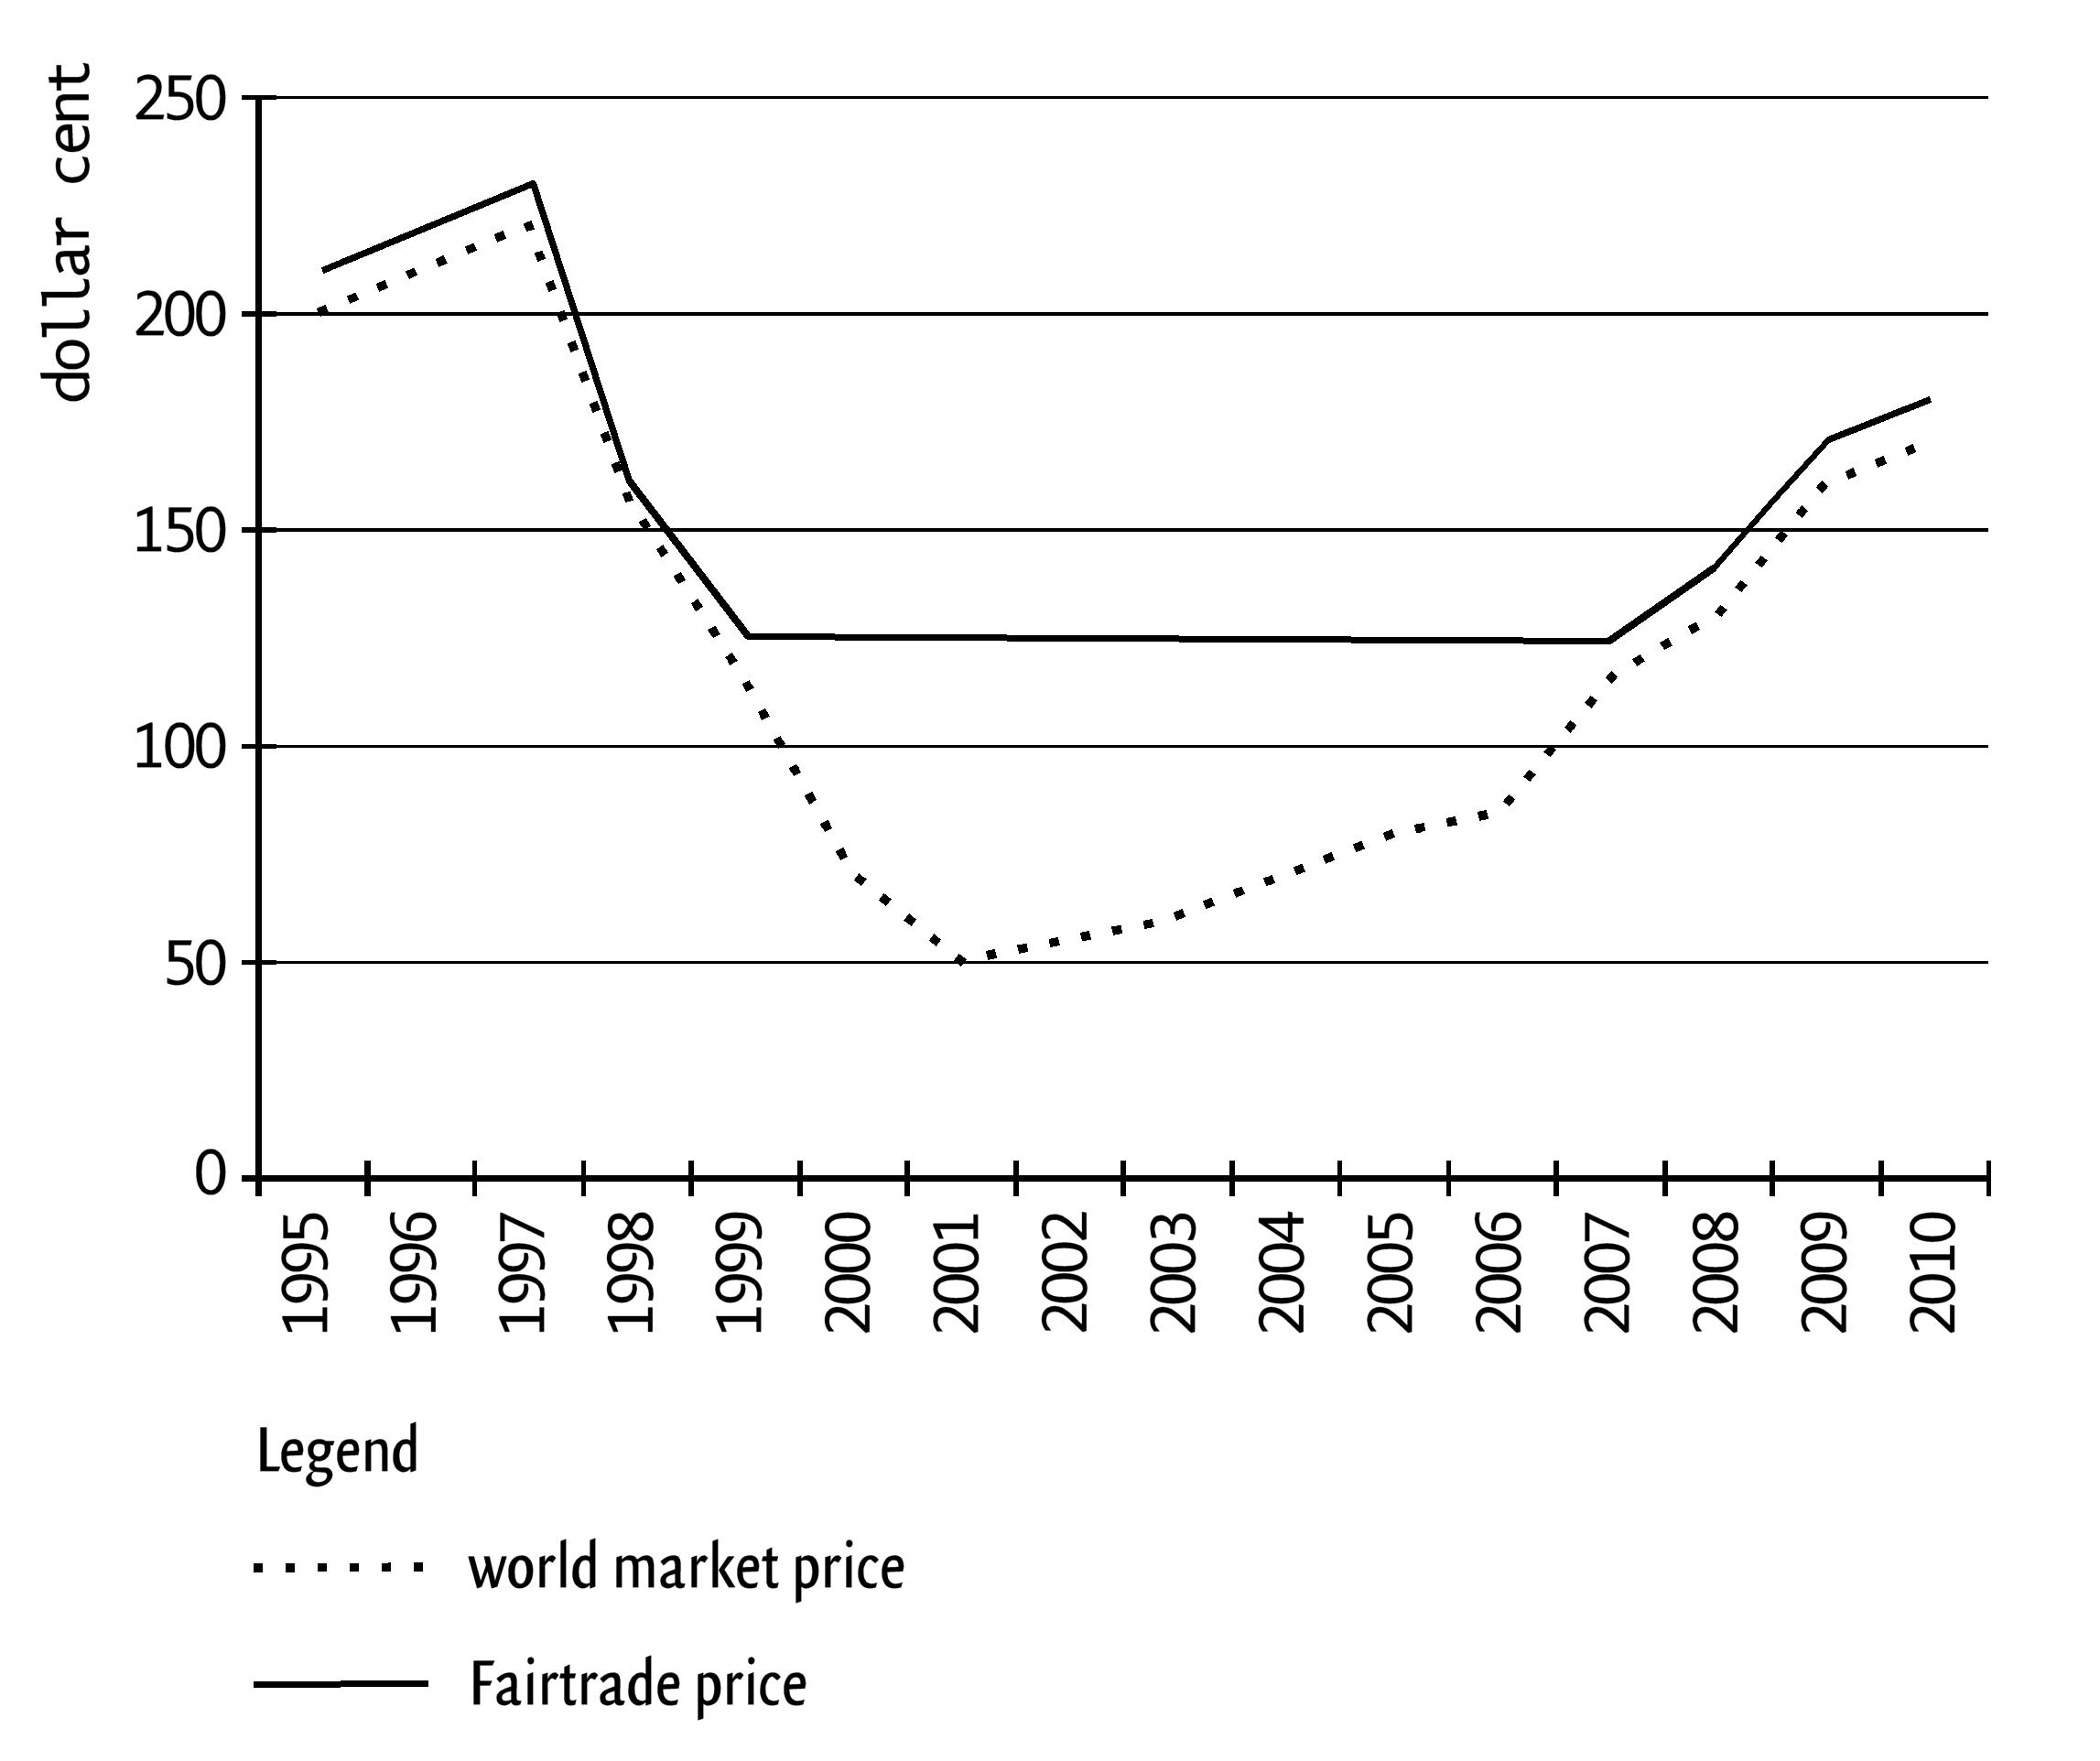

Exercise 1.5 One for all, all for one!
Roel and Linda are both in 4 vmbo-t. In their economy lesson they are working on a project about the economic dependence of the Netherlands on foreign countries. Their teacher indicates that this dependence is very high. He says that 70% of our national income is earned with export.
Roel says to Linda: “I wonder whether this dependence of the Netherlands on foreign countries is really that high. I want to investigate this.”

Linda says: “Maybe we can start with Dutch cheese. It is always claimed that we export so much cheese.” “Okay”, says Roel, “I found some data about this on a site.”

The overview below shows how much cheese has been produced and eaten in the Netherlands and exported abroad in the past few decades.
 | 1990 | 2000 | 2010
production × 1 million kilogram | 601 | 660 | 738
export × 1 million kilogram | 433 | 498 | 563
consumption in the Netherlands per inhabitant in kilos | 13.6 | 15.82 | 18.0

- What percentage of the Dutch cheese was exported in 2010? Write down your calculation.
Linda looks at the table and calculates how many kilos of Dutch cheese were eaten by all the Dutch inhabitants in 2010. Thereby she assumes that there are 16 million inhabitants in 2010. Linda discovers that there is a shortage of more than 100 million kilos of cheese in 2010. Roel says to her:
“That is not a shortage. That is what we have imported.”
- Calculate how many kilos of cheese were imported in 2010.

“Well, around three-quarters of the cheese we produce is going abroad”, says Linda. “Let us now look at the services sector, for the Netherlands provides many services in and to foreign countries.”

In addition to goods, services are provided as well.
- What is understood to be a service in economy?
- A service is an agreement that is laid down in a written contract.
- A service is a social institution that supports certain population groups.
- A service is a non-material good.
- A service is an obligation that you enter into for a certain period.

Transport is one of the services which the Netherlands provides to foreign countries. Think of road transport, for example, but also of inland waterway transport and air traffic. “So when KLM flies an American tourist to the Netherlands, that is a service”, Linda says to Roel.

- What does the transport by KLM an American tourist to the Netherlands belong to and why?
- This belongs to export, because services are provided to a foreign country.
- This belongs to export, because persons are going abroad.
- This belongs to import, because services are provided to the Netherlands.
- This belongs to import, because persons are coming to the Netherlands.

Transport performance 2003-2009
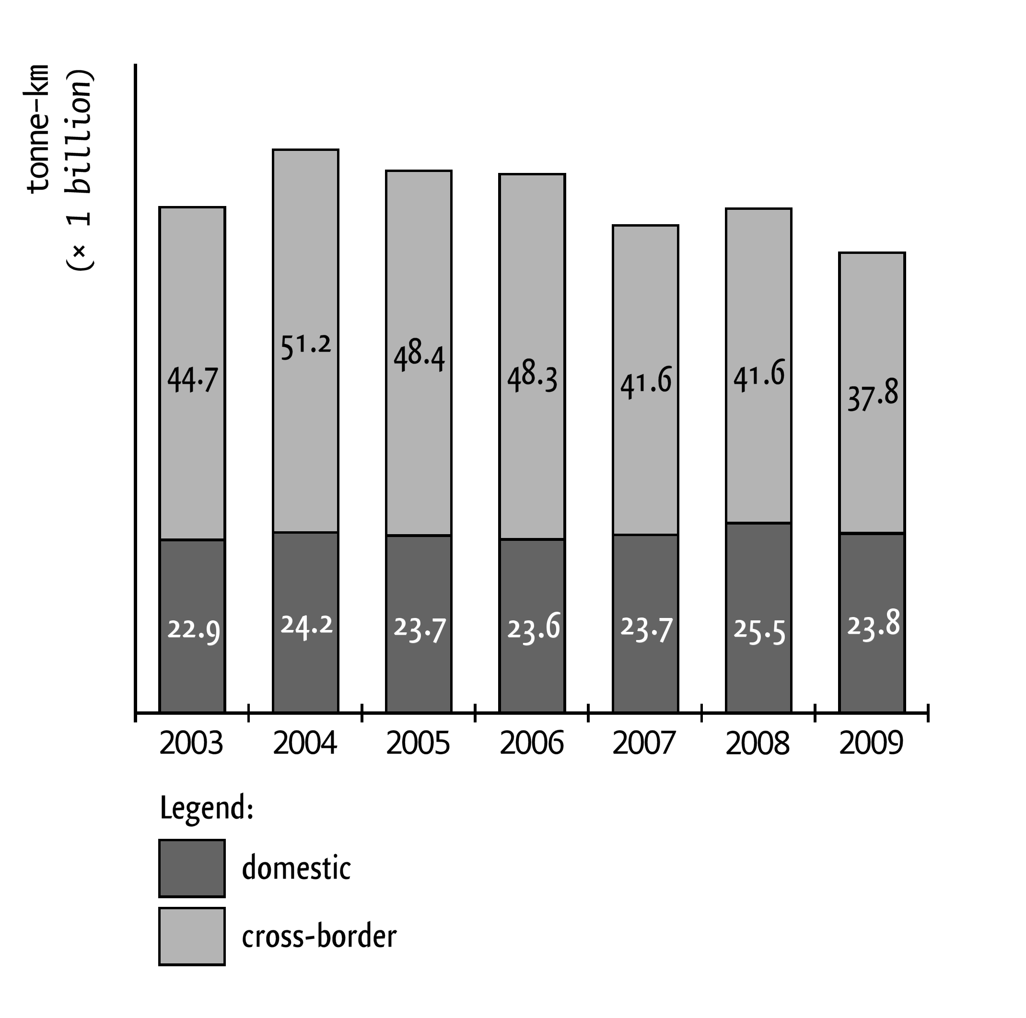

Roel says: “Transport is very important for export and import. How much do Dutch carriers actually transport?” They study the graph about the Transport performance from 2003 to 2009 inclusive.
“What exactly is a tonne-kilometre (tonne-km)?”, asks Linda. “That means that a tonne of weight has been transported by one kilometre”, says Roel. “When you transport half a tonne by 2 kilometres, that is also 1 tonne-kilometre.”
- Give the reason why the number of tonne-kilometres for cross-border runs is much larger than for domestic runs.

Linda thinks that inland waterway transport will grow strongly at the cost of road transport.
- Name an advantage of inland waterway transport over road transport.

The transport sector benefits a lot from the membership of the Netherlands of the European Monetary Union (EMU), such as free movement of goods, services and persons.
- Mention another characteristic of the EMU which is beneficial for the Dutch transport sector.

It is in the interest of the Netherlands that goods can be transported abroad as cheaply as possible. The EU contributes to this also. Nevertheless, Dutch carriers must pay toll when using roads abroad. Domestic carriers pay as much toll in their own country as foreign carriers.
Roel finds it odd that Dutch carriers must pay toll when using roads abroad. “Surely that is against the European idea,” he says. “Europe should see to it that this is abandoned,” he says. Linda finds it a matter of course that some countries levy toll.
- What do you think: Can other European countries levy toll when foreign carriers use their roads? Give an argument for your opinion.

Exercise 1.6 Indexes
Cindy Kappers has made an overview of the sales and the price of the Nordman (Christmas tree).
(1) | (2) | (3) | (4) | (5) | (6)
 | Sales | Price | Turnover | Sales index | Price index
2010 | 1,000 | € 30 | € 30,000
2011 | 1,200 | € 28 | € 33,600
2012 | 1,250 | € 26 | € 32,500
2013 | 1,400 | € 25 | € 35,000
2014 | 1,600 | € 20 | € 32,000
- Complete column (5) with the turnover indexes. Take 2010 as the basis.
- Complete column (6) with the price indexes. Take 2014 as the basis.

Computations exercises Society chapter 1

Exercise 1.1
The British pound sterling has decreased in value. In May 2017 you received 0.83 British pound for 1 euro, in September you got 0.925 British pound for 1 euro.
Exercise 1.2
- € 1.27 = GBP 1
€ 600 = GBP 1 × 600/1.27 = GBP 472.44.
- GBP 0.76 = € 1
GBP 60 = € 1 × 60/0.76 = € 78.95.
Spent: 600 ─ 78.95 = € 521.05.
Exercise 1.3
$ 1.22 = 147.08 yen.
$ 399 = 147.08 × 399/1.22 = 48,102 yen.
Exercise 1.4
- (163-78) / 78 x 100% = 108.97% increase
- D
- B
Exercise 1.5
- 563 million kg / 738 million kg x 100 % = 76.3%
- • 18 kilo x 16 million = 288 million kg consumption in the Netherlands.
Available for consumption: 738 million kg – 563 million kg = 175 million kg.
• 288 million kg – 175 million kg = 113 million kg import.
- C
- A
- In case of cross-border traffic the distances and/or the tonnages are usually larger than for domestic transport.
- – Inland waterway transport emits less CO2 and particulates (per tonne-kilometre) than road transport.
− Inland waterway transport is affected less by congestion.
- − The use of the euro within the euro zone
− Common levies on import
- Examples of a correct argument if you have answered yes:
− Those countries have to spend money on the maintenance of their roads. It is reasonable that users share in the costs of this.
− As a result you get fair competition between domestic and foreign carriers.
Example of a correct argument if you have answered no:
All European countries have an interest in good and cheap transport. If everybody can use each other’s roads, this saves time and money.
Exercise 1.6
- See table
- See table
(1) | (2) | (3) | (4) | (5) | (6)
 | Sales | Price | Turnover | Turnover index | Price index
2010 | 1,000 | € 30 | € 30,000 | 100.0 | 150
2011 | 1,200 | € 28 | € 33,600 | 112 | 140
2012 | 1,250 | € 26 | € 32,500 | 108.3 | 130
2013 | 1,400 | € 25 | € 35,000 | 116.7 | 125
2014 | 1,600 | € 20 | € 32,000 | 106.7 | 100

